**Massachusetts Institute Of Technology** Summer 2015

Precision Motion Control Lab

myRIO Dynamic Signal Analyzer Documentation

1. Overview:
   1. The myRIO Dynamic Signal Analyzer (DSA) is designed to be used as a subVI **(Dropable_DSA.vi)** that can be simply dropped into new and/or existing control and/or simulation code to measure a desired frequency response and plot it as the corresponding Bode plots.
   2. DSA Inputs/Outputs:

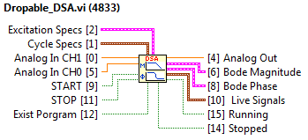

* + 1. Inputs:
       1. Excitation Specs **[Cluster]**
          1. Initial Frequency **[Double]**

The lowest frequency of the frequency range which the DSA will measure the bode plot for.

* + - * 1. Final Frequency **[Double]**

The highest frequency of the frequency range which the DSA will measure the bode plot for.

* + - * 1. Frequency Units **[Boolean]**

Whether the frequency range input is in Hz or rads/sec.

TRUE = Hz | FALSE = rads/sec

* + - * 1. Number of Frequencies **[Integer]**

The number of logarithmically spaced frequencies to measure the bode plot for.

* + - * 1. Sampling Time **[Double]**

The time step taking in between each measurement.

* + - * 1. Amplitude **[Double]**

Amplitude of desired swept sine excitation.

* + - * 1. Offset **[Double]**

DC offset of swept sine excitation.

* + - 1. Cycle Specs **[Cluster]**
         1. Cycles to Settle **[Integer]**

The number of cycles of the swept sine wave at each frequency to ignore to let the transient response die out.

* + - * 1. Cycles to Calculate **[Integer]**

The number of cycles of the sept since wave at each frequency to measure in order to measure the bode plot.

* + - 1. Controls:
         1. START **[Boolean]**

Tells the DSA to initialize and then start.

TRUE = Start/Restart and initialize the DSA | FALSE = Nothing

* + - * 1. STOP **[Boolean]**

Tells the DSA to stop and set all analog outputs to zero.

TRUE = Stop the DSA | FALSE = Nothing

* + - * 1. EXIT PROGRAM **[Boolean]**

Tells LabVIEW to set all analog outputs to zero and exit the program.

TRUE = Stop the DSA & execute exit program code | FALSE = Nothing

* + 1. Outputs:
       1. Running **[Boolean]**
          1. Signal to show if the DSA is running.
          2. TRUE = Tells the DSA to keep running (since start is an initialize button) | FALSE = Nothing
       2. Stopped **[Boolean]**
          1. Signal to show if the DSA is stopped (Visual counterpart to Running)
          2. TRUE = Indicates that the DSA has stopped | FALSE = Nothing
       3. FINISHED LATE **[Boolean]**
          1. Signal to show if the DSA is running slower than the desired sampling rate.
          2. TRUE = Indicates the myRIO cannot keep up with the desired sampling rate | FALSE = Nothing
       4. Bode Magnitude **[Cluster]**
          1. The magnitude plot of the TF CH1/CH0.

x = List of Frequencies **[Array of Doubles]**

y = List of Magnitudes **[Array of Doubles]**

* + - 1. Bode Phase **[Cluster]**
         1. The phase plot of the TF CH1/CH0.

x = List of Frequencies **[Array of Doubles]**

y = List of Phases **[Array of Doubles]**

* 1. Example Code
     1. Stand-Alone DSA: Example code on how to use the Dropable_DSA.vi inside a timed while loop.

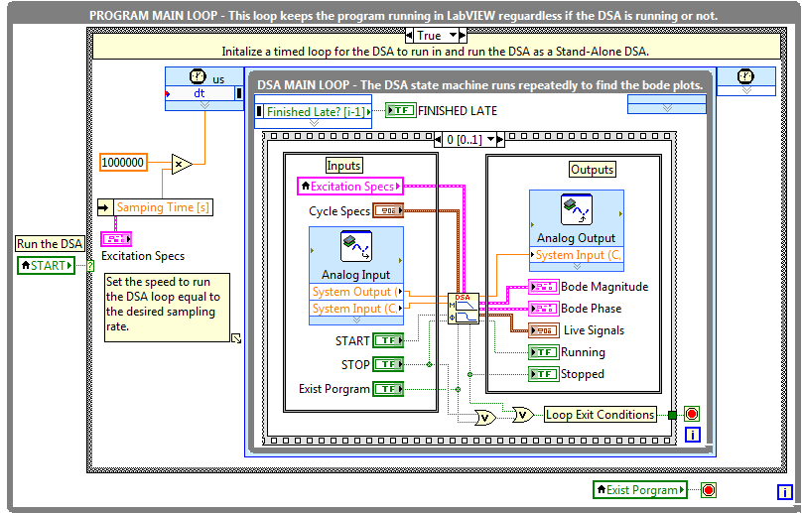

* + 1. Embedded DSA: Example code on how to use the Dropable_DSA.vi with a simulated controller.

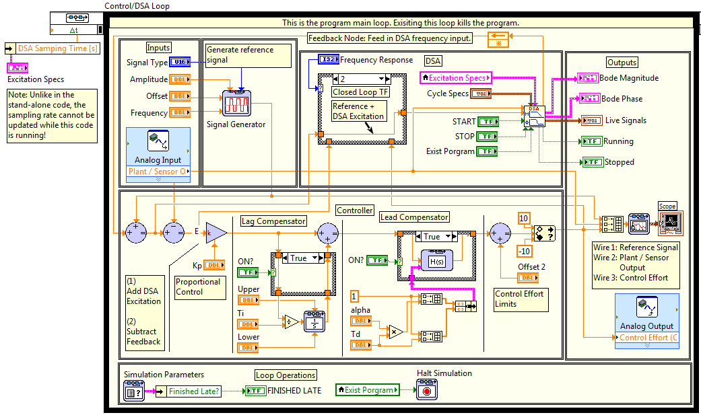

1. Code Internal Structure
   1. For the internal code structure. see the documentation (help) for each subVI.